**Files:**

- Named locations on a computers disk that permanently store information for future use (stored on non-volatile memory as apposed to RAM)  
**- File Handling** – the process that a language uses to interact with a computers file system  
1). Open/Create the file  
2). Perform operations on the file (read, write, delete, etc..)  
3). Close the file to free up resources used  
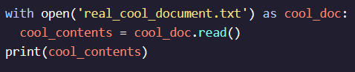

**Iterating Through Lines:**

- Can use *.readlines()* to read a text file line by line and return as a list of strings  
- Memory intensive if file is large  
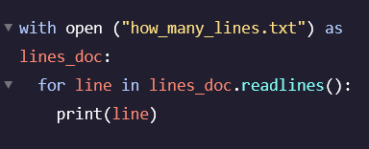 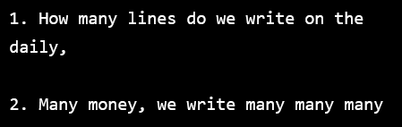

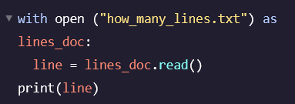 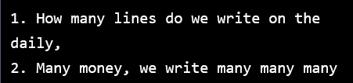

**Reading a Line:**

- Use *.readline()* to read only one line from the file each time it’s called  
- Reads until encounters end of line and then returns “ “   
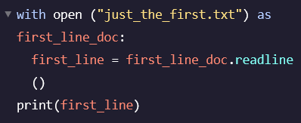 

**Writing a Line:**

- Can also add text into a file once it’s open using the *.write()* function  
- Default mode when opening file is read (‘r’) so need to pass (‘w’) after text file name to indicate to Python it should be opened in write mode  
- The new file will overwrite your old file  
- Can’t read from a file opened in write mode! Need to reopen in read mode  
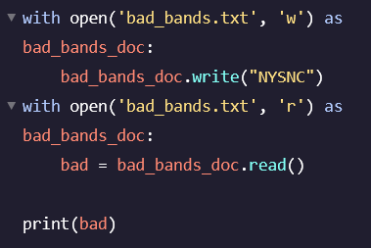

**Appending to a File:**

- Allows you to add to an existing file without you needing to overwrite